**­­­­­­Quick Start Guide for Librarian System Users:**

1. First connect to the mysql server.
2. After successful compiling, run the application
3. The following Home Search Screen should appear, from here you can use the following functions:  
   1. **Searching:**

This home screen will allow you to type and search for isbn, book, and author data for any matching string, a resulting table of results will then be shown

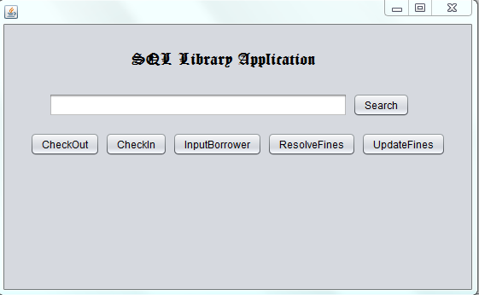

* 1. **Checking Out Books:**

After clicking the “CheckOut” button, a window will prompt for you to enter the correct card id of the borrower and book isbn number. They both MUST be filled correctly, then press “Check Out” to check the book out.

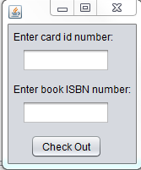

* 1. **Checking In Books:**

After clicking the “CheckIn” button, a screen will appear that will allow you to use either isbn or card id or borrower name to search for a book to check back in:

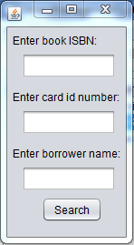

After clicking “Search”, a table will display on a new table with the book loan information. After finding the specific book to check in, type that associated book loan into the check in field and press “Check In” to check in the book.

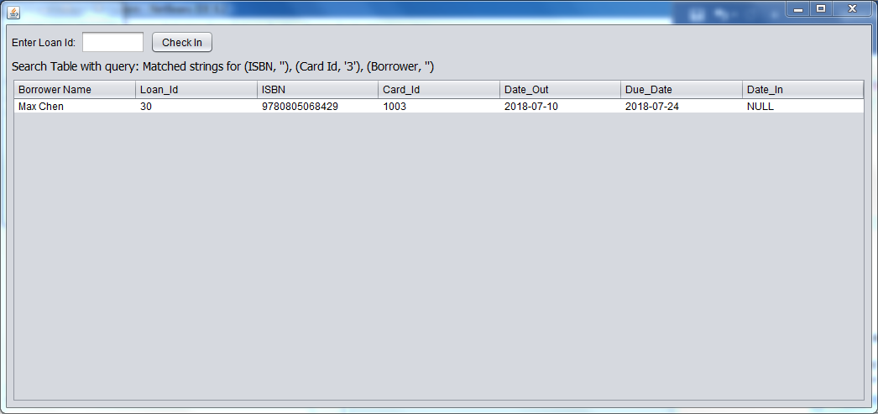

* 1. **Register new borrowers to the system:**

After clicking “InputBorrower” button, a window will appear that will prompt you fields in order to register a borrower. A unique Ssn, name, and address are required fields.

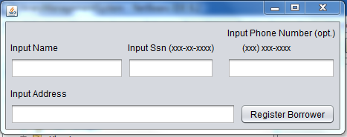

* 1. **Update fines:**

After clicking the “UpdateFines” button, it will update the fines associated with all users that have overdue books.

* 1. **Resolve fines:**

After clicking the “ResolveFines” button, it will display the card id of all the borrowers who have current fines. After entering their card id number, it will resolve them of all their fines.



